2. Demonstrate use of abstract class, multiple inheritance and decorator in

python using examples.

Abstract class: An abstract class can be considered as a blueprint for other classes. By defining an abstract base class where we can define a common Application Program Interface(API) for a set of subclasses.

Example:

In python ,it does not provide abstract classes,Python comes with a module that provides the base for defining Abstract base classes(ABC) and that module name is ABC.

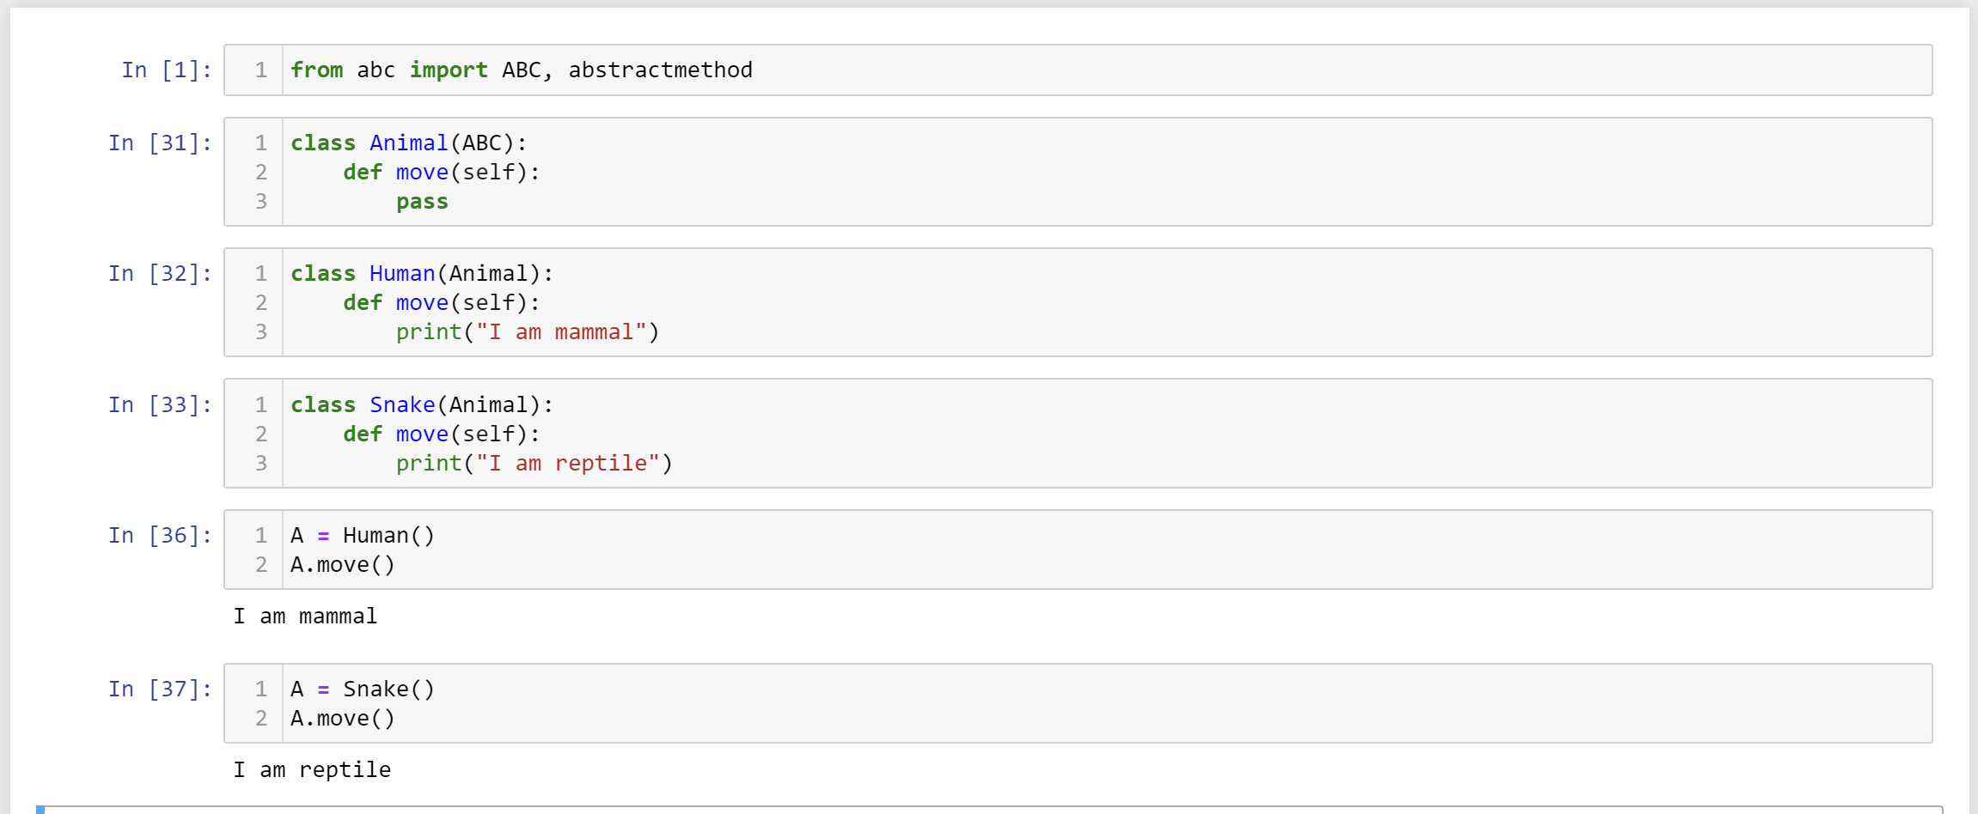

Multiple inheritance:

When the class is derived from more than one base class is called multiple inheritance.  
the derived class inherits all the features of the base class.

Example:

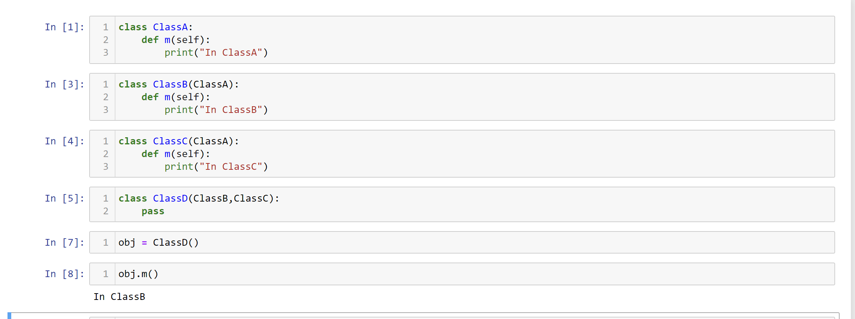

Decorator:

Decorators are used to modify the behaviour of function or class. In Decorators, functions are taken as the argument into another function and then called inside the wrapper function.

